James Abundis and Thomas Fahrner

4/17/18

CSC 466

Skyline Report

*EXTENDED BAKERY*

minSup = 0.02

minConf = 0.75

These parameters were chosen by initializing at very low values and plotting the scatter of minSup vs minConf. We looked for clustering and found that there was a significant cluster beyond 0.02 support and 0.75 confidence.

Skyline itemsets of length 1 are omitted.

* 1000i.csv
  + Skyline itemsets
  + 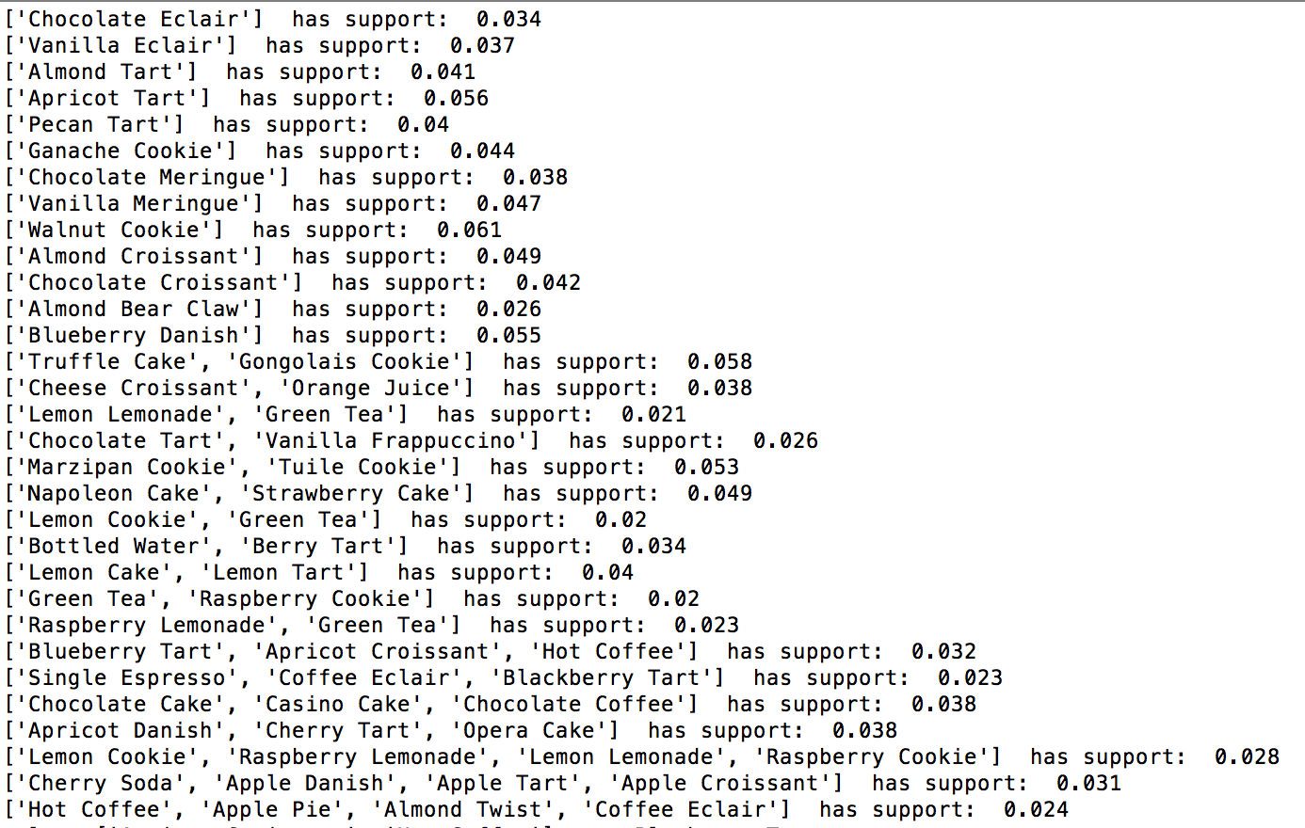
  + Skyline association rules
  + 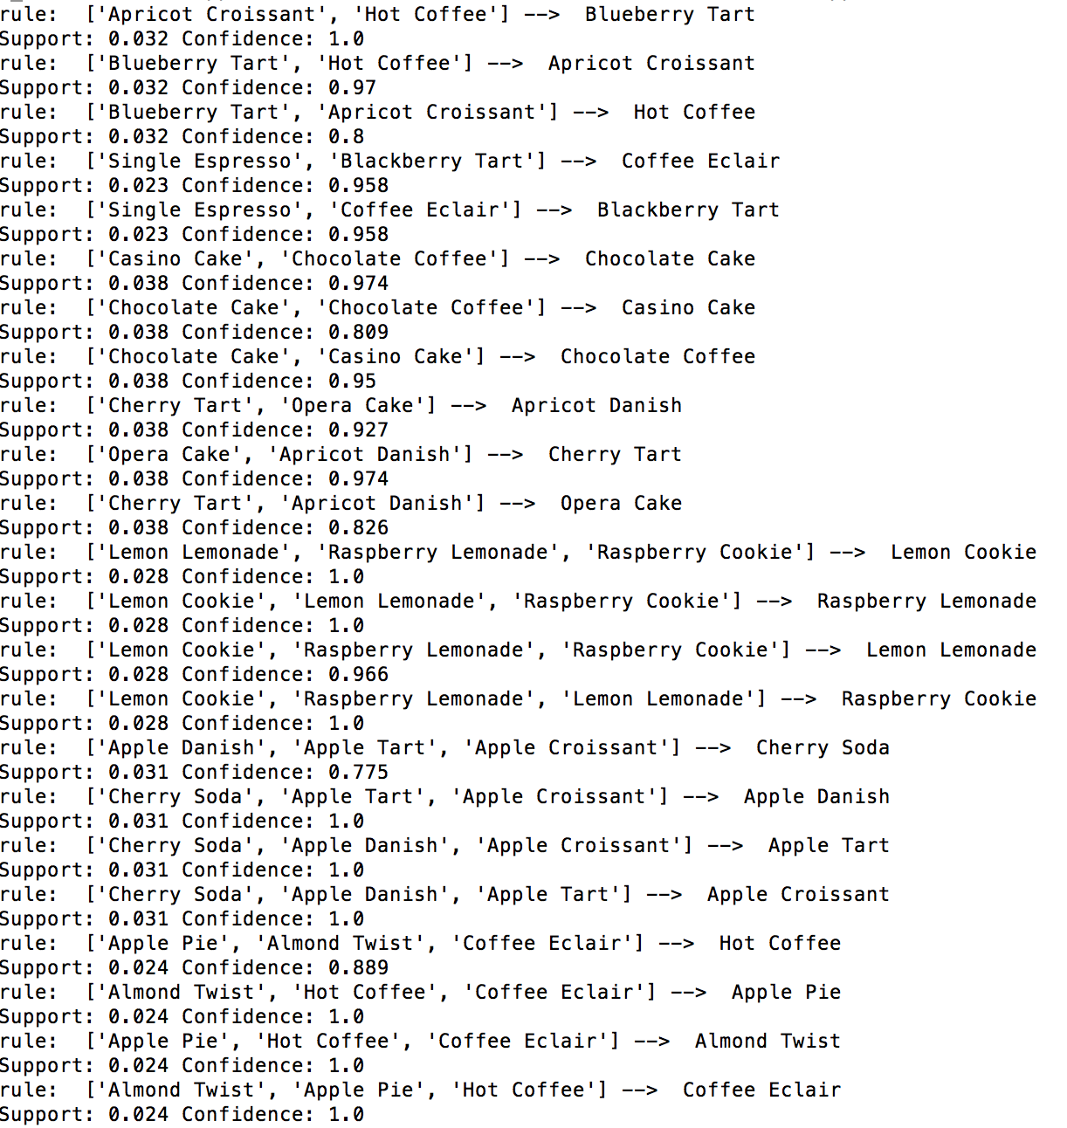
* 5000i.csv
  + Skyline itemsets
  + 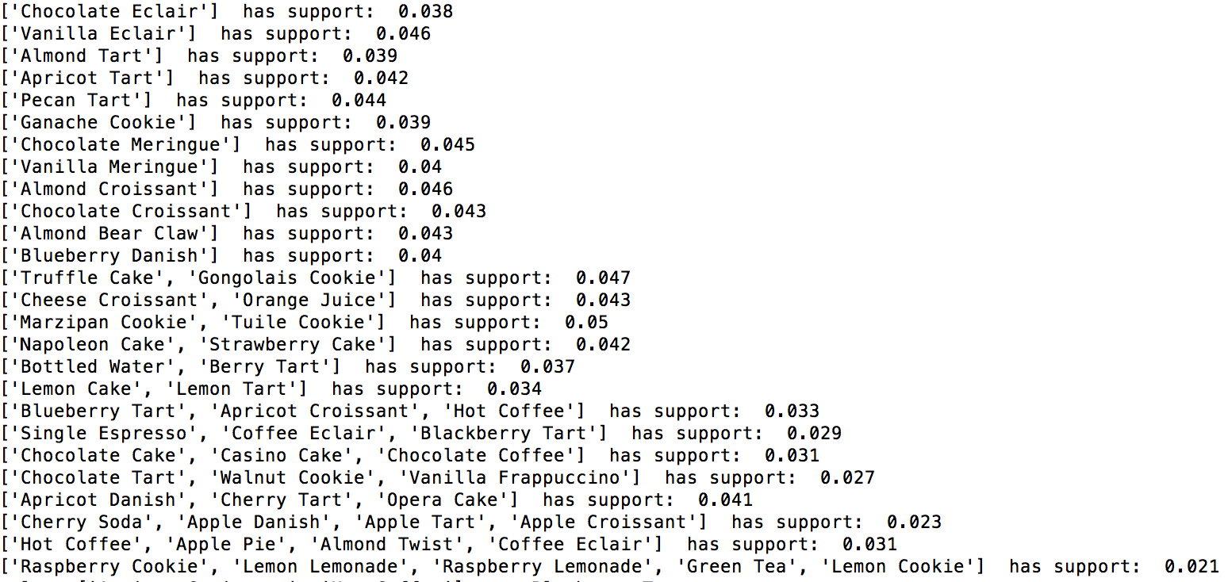
  + Skyline association rules
  + 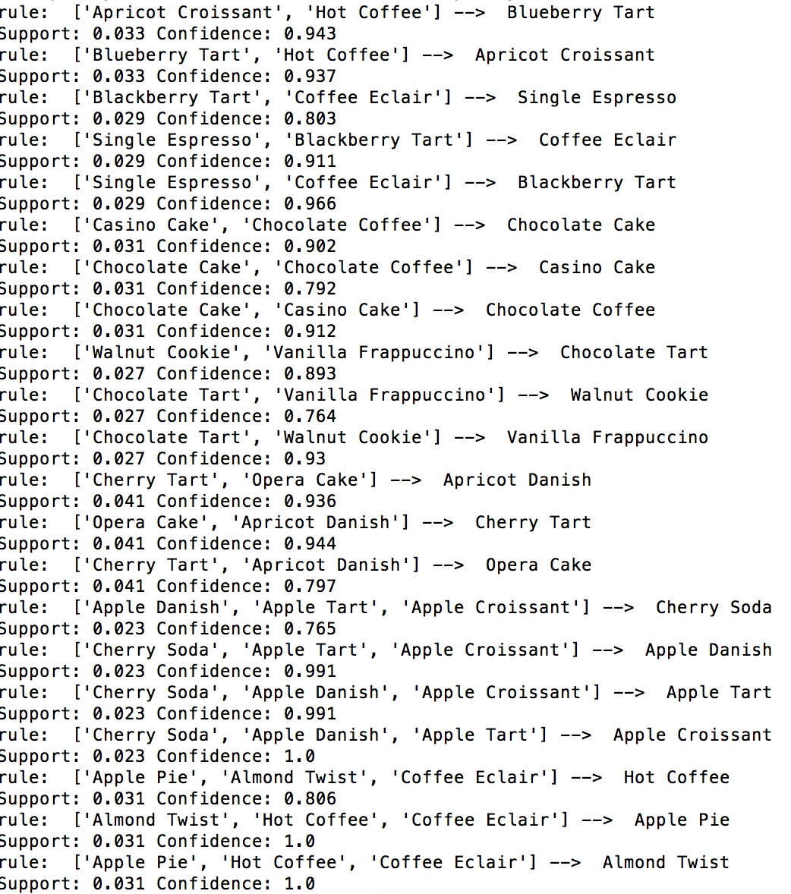
  + 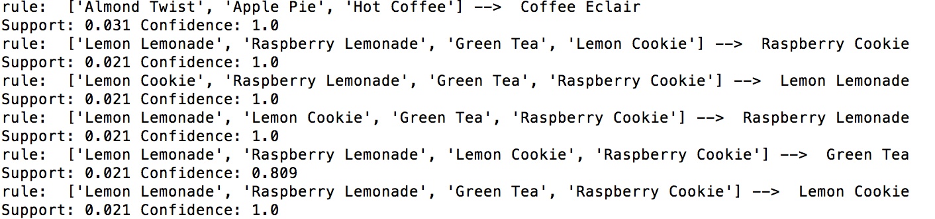
* 20000i.csv
  + Skyline itemsets
  + 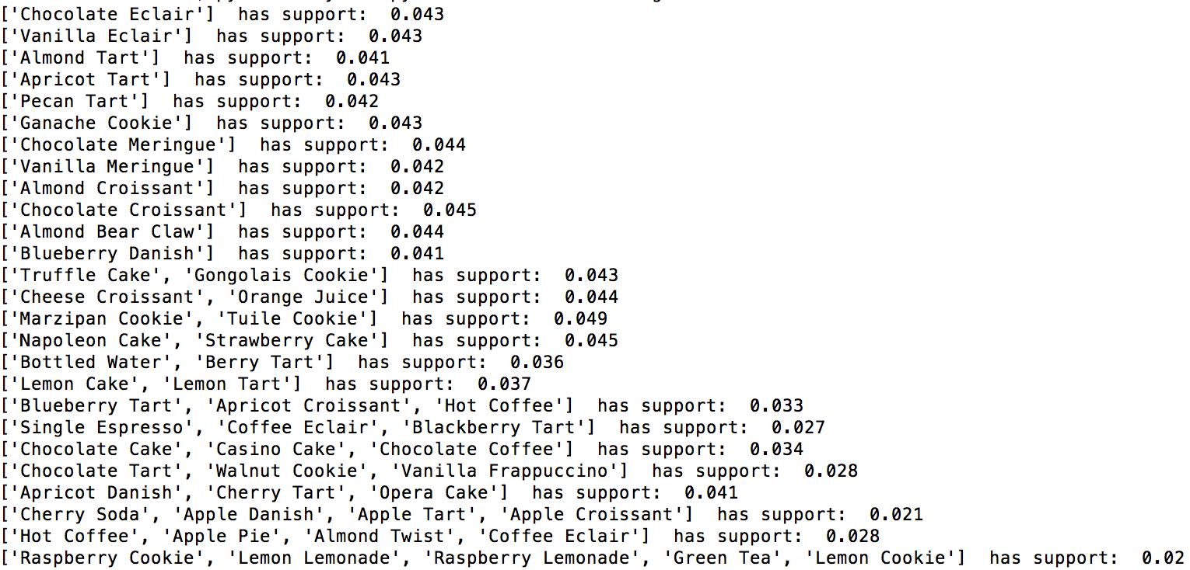
  + Skyline association rules
  + 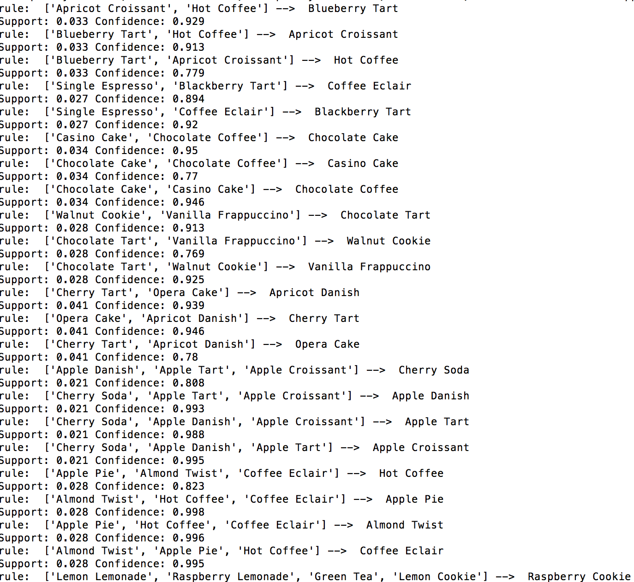
  + 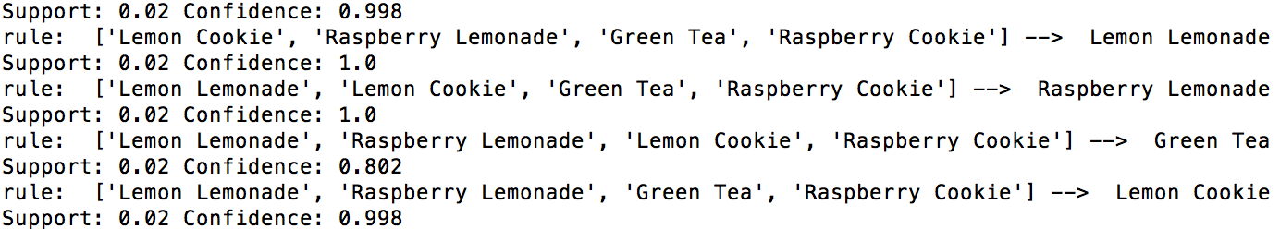
* 75000i.csv
  + Skyline itemsets
  + 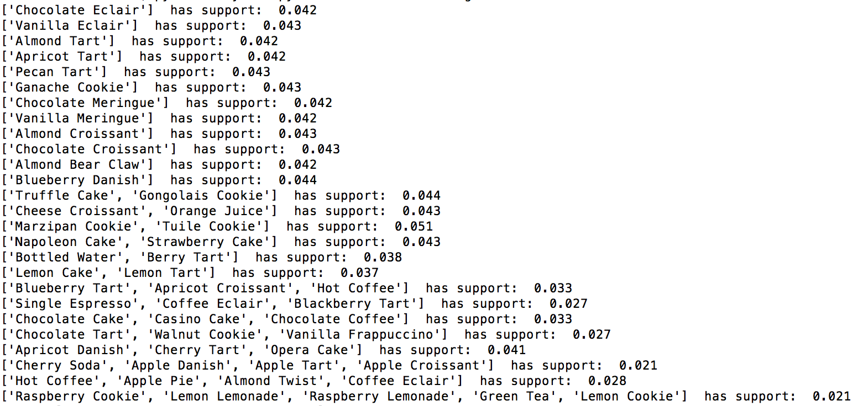
  + Skyline association rules
  + 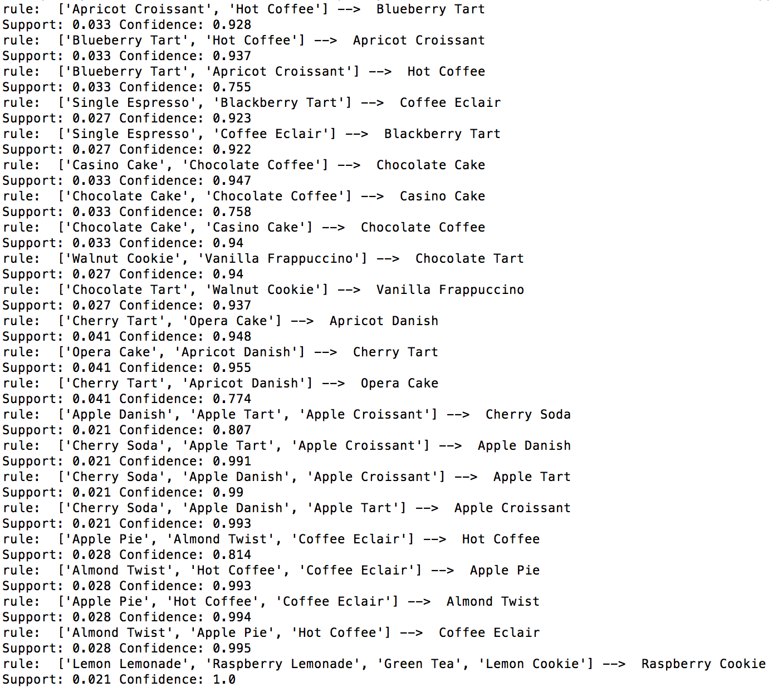
  + 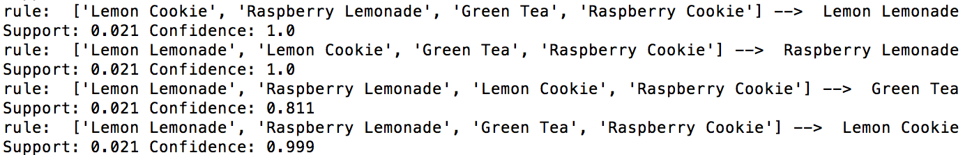

*Fantasy Bingo*

minSup = 0.09

minConf = 0.42

These parameters were chosen to give a sampling of itemsets with 3 authors in them as well as association rules from two authors to a third. Lowering the minSup further explodes the number of significant itemsets of one author. The minConf behaves similarly. By decreasing the minSup while maintaing the minConf we can see some interesting association rules between authors.

Skyline itemsets of length 1 are omitted.

* bingoBaskets.csv
  + Skyline itemsets
  + 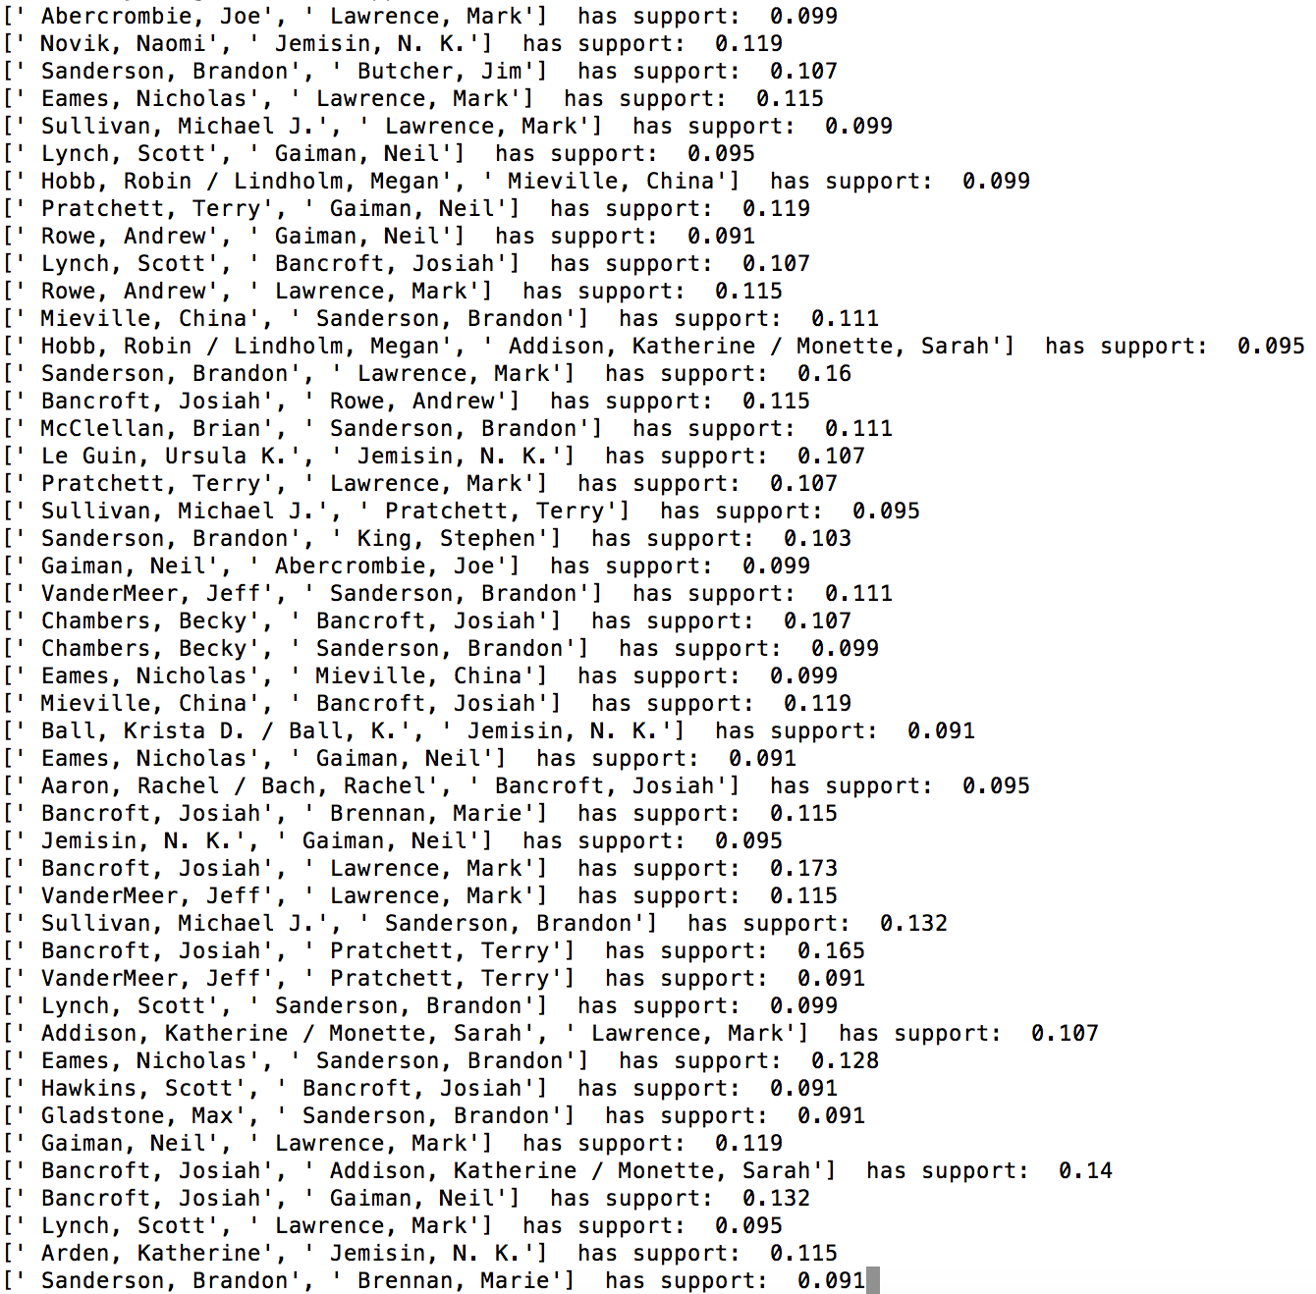
  + 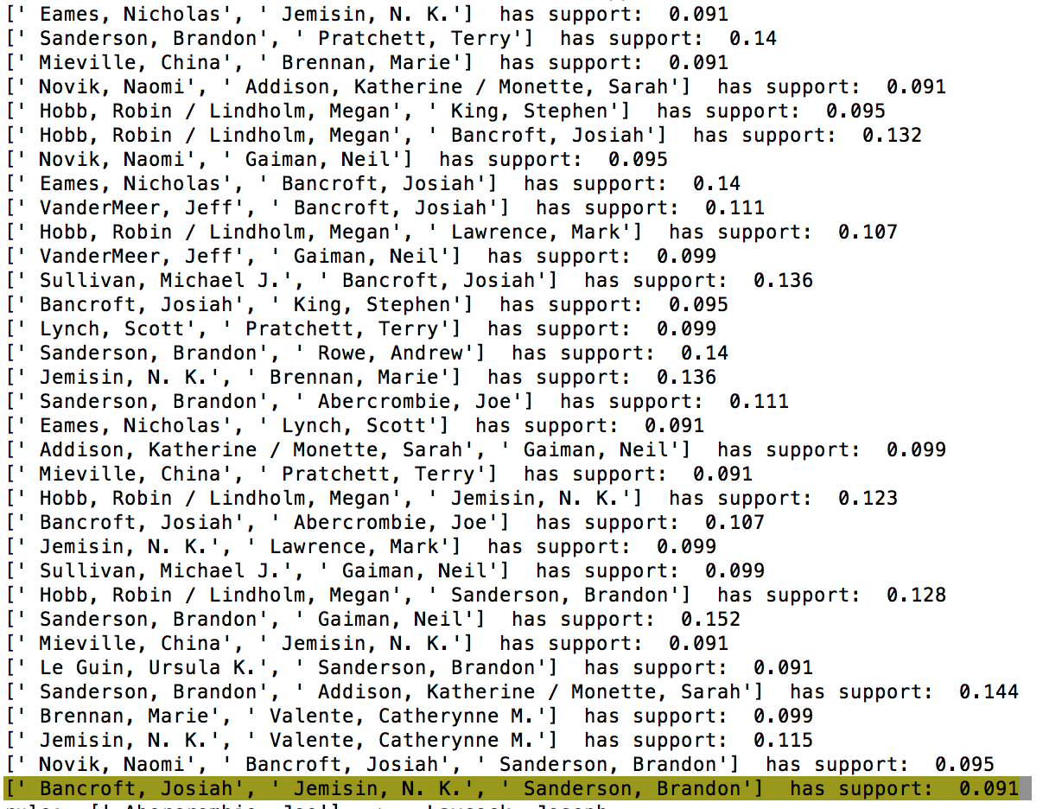
  + Skyline association rules
  + 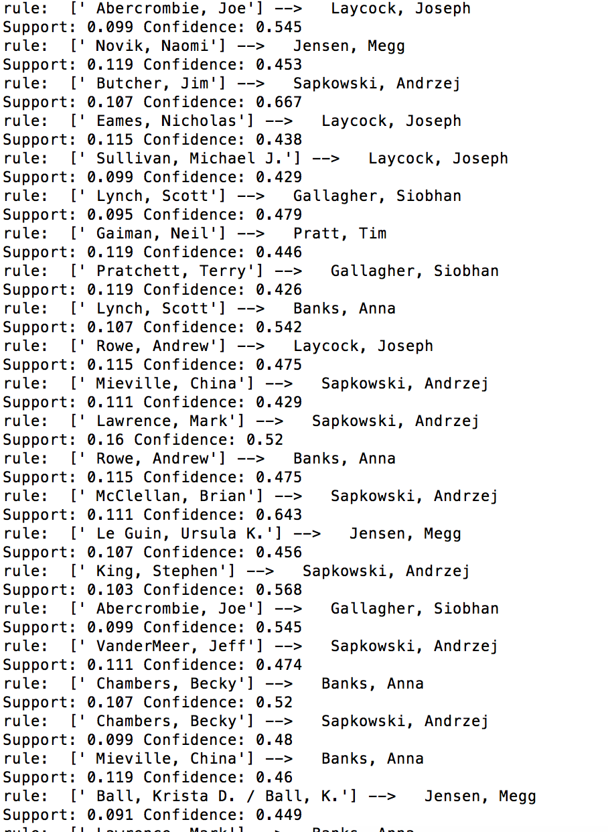
  + 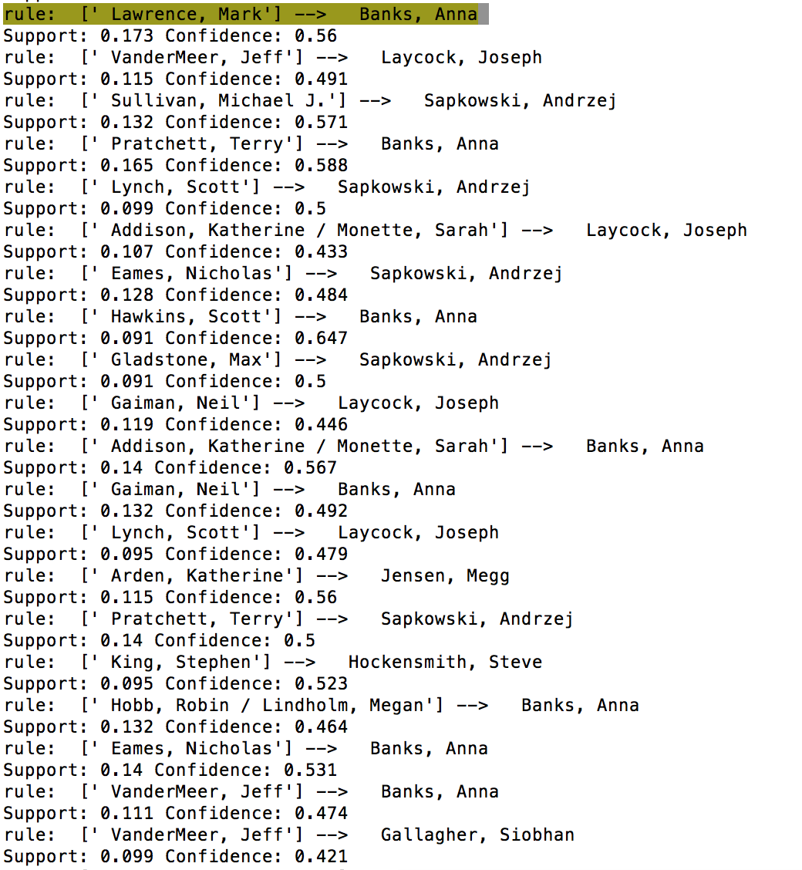
  + 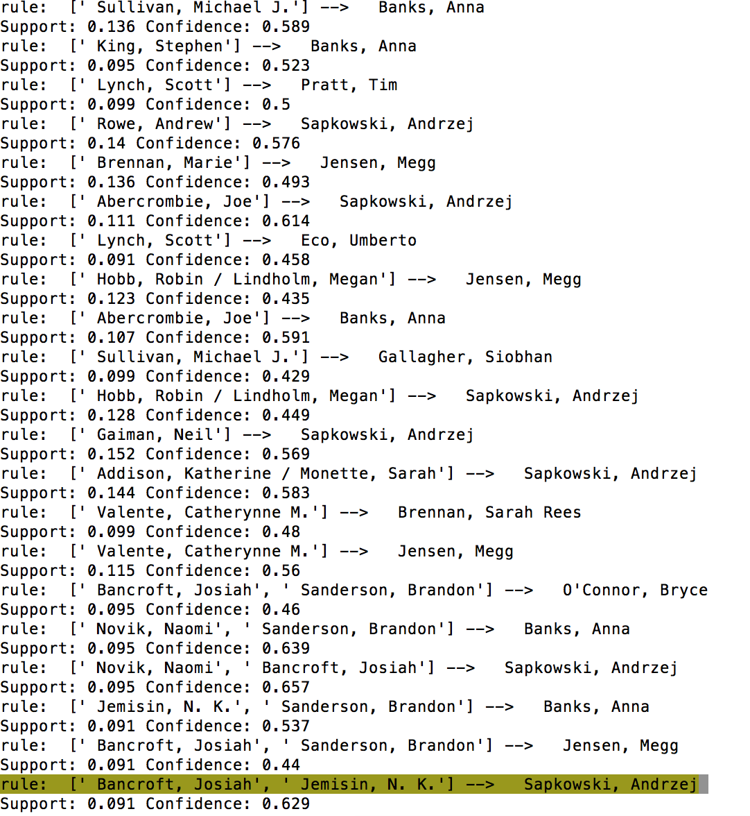

*Transcription Factors*

minSup = 0.6, maxSup = 0.85

maxSup was chosen because nearly every item that has a support beyond 0.85 occurs in every market basket (super frequent items)

* factor_baskets_full.csv
  + super frequent items:
  + 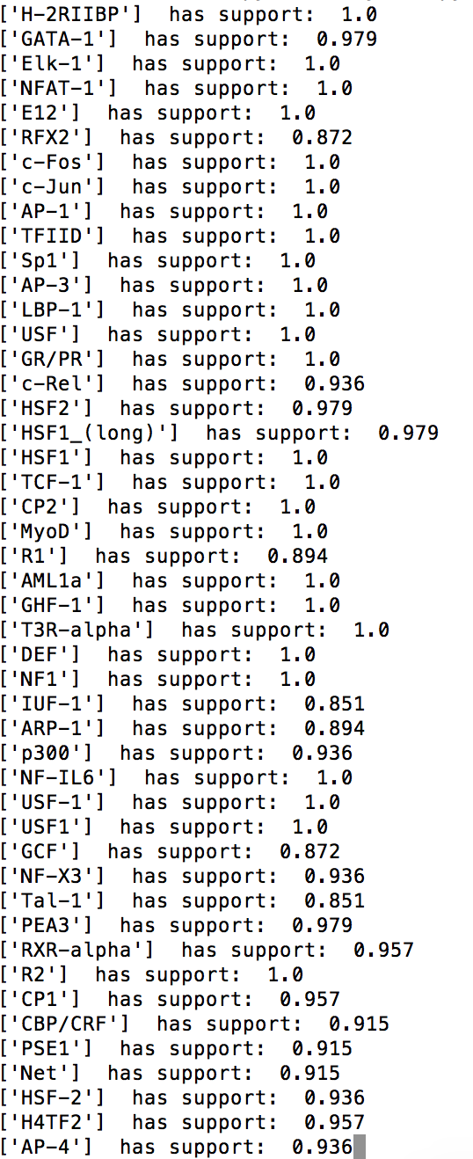
  + 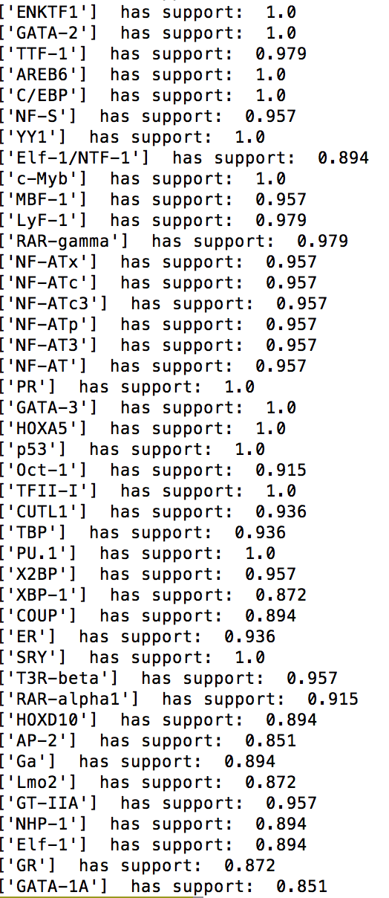

Skyline itemsets (Skyline itemsets of length 1 are omitted.)

* + 
   